Objective: To promote safe stair use behaviors to minimize fall risks

Many falls occur on stairs. Employers are responsible to follow construction requirements to make stairs and handrails as safe as possible. However, employees also have a responsibility to use safe behaviors to minimize the risk of a fall.
Safe Behaviors
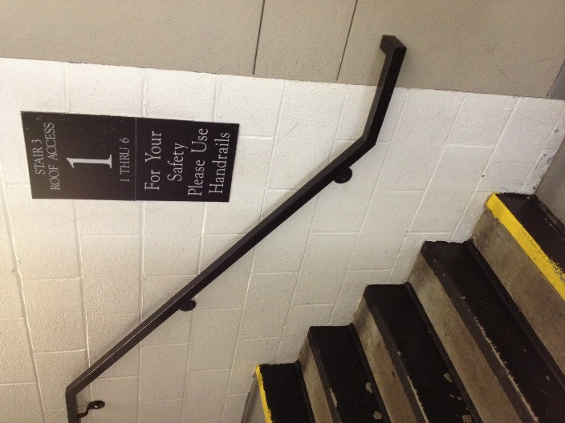
- Always use the handrails when ascending and descending stairs.
- Do not rush on the stairs.
- Be cautious and focused, not distracted. (For example, do not use your cell phone while on stairs)
- Check for hazards, like clutter or slippery surfaces.
- Wear properly fitting shoes with anti-slip soles.
- Know the effects of any type of medication you are taking that could affect your balance or depth perception.
- Never carry large objects that block your view or require both hands. Keep one hand free to hold on to a handrail.
- Stay to the right when others are on the stairs.
- Clean up clutter and spills on stairs immediately.
- Report damaged or defective stairs or inadequate lighting to management.

This form documents that the training specified above was presented to the listed participants. By signing below, each participant acknowledges receiving this training.

Organization: Date:

Trainer: Trainer’s Signature:

Class Participants:

Name: Signature:

Name: Signature:

Name: Signature:

Name: Signature:

Name: Signature:

Name: Signature:

Name: Signature:

Name: Signature:

Name: Signature:

Name: Signature:

Name: Signature:

Name: Signature:

Name: Signature:

Name: Signature:

Name: Signature:

Name: Signature:

