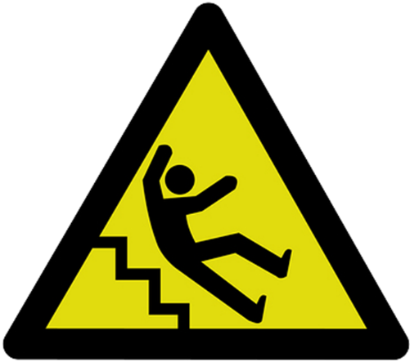
Slips, trips and falls constitute the majority of general industry accidents. According to OSHA, they cause 15% of all deaths, and are second only to motor vehicles as a cause of fatalities. Slips, trips and fall hazards also need to be controlled for visitors.

Falls can result in substantial worker compensation and general liability claims. Fall prevention programs should examine the sources of falls and pay particular attention toward surface traction, contaminant control, proper footwear and training.

Controls: Following established health and safety rules not only ensures safe conditions, it creates a safety conscious culture and shields your organization from possible claims or compliance issues. A checklist similar to the example below should be developed and made specific to hazards present in sites. This observation approach needs to be part of a Slip, Trip and Fall Prevention Program.

Yes No
- □ Is there standing water in a work environment?
- □ Do employees wear proper shoes?
- □ Are areas poorly lit?
- □ Have walkways and floors been treated with anti slip surfaces where needed?
- □ Are all walking surfaces even?
- □ Does clutter obstruct hallways, walk or work areas?
- □ Is matting and carpeting free of wrinkles?
- □ Are cables properly covered?
- □ If an area has a wet surface, is it appropriately marked?
- □ Are designated walkways established and running controlled?
- □ Are stairs and any elevated areas properly protected?
- □ Does your organization have a proactive program for frequent area inspections,
snow and ice removal, corrective action process, an anti-slip shoe program, and a
training process in place?

Conclusion: It’s not enough to have policies and procedures, there must be a process in place to assure all safe practices are known and followed. It is essential to identify areas of concern and exposures, and to develop effective controls to prevent injuries from occurring. Working together will build a safety conscious culture and help to ensure a safe and healthful organization for employees and visitors.

This form documents that the training specified above was presented to the listed participants. By signing below, each participant acknowledges receiving this training.

Organization: Date:

Trainer: Trainer’s Signature:

Class Participants:

Name: Signature:

Name: Signature:

Name: Signature:

Name: Signature:

Name: Signature:

Name: Signature:

Name: Signature:

Name: Signature:

Name: Signature:

Name: Signature:

Name: Signature:

Name: Signature:

Name: Signature:

Name: Signature:

Name: Signature:

Name: Signature:

