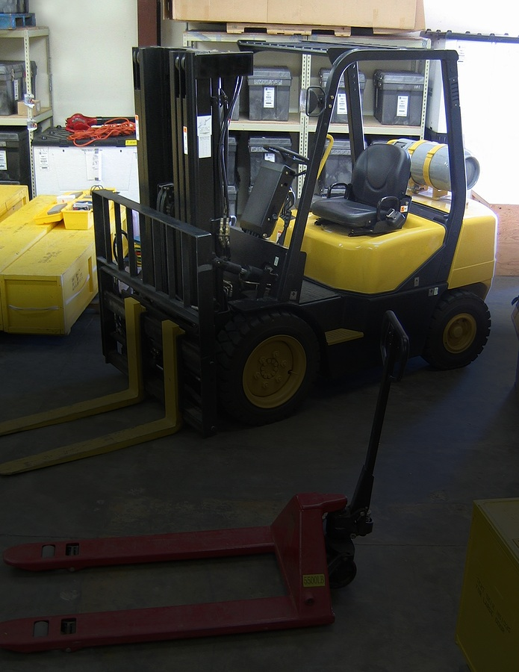

**Forklift Safety**

**Pedestrians and other employees:**

* Keep clear of forklifts that are in operation.
* Stay in designated areas and walkways.
* Assume the operator does not see you.
* Be aware that forklifts cannot stop suddenly.
* Stay alert when near the back of a forklift—it swings widely when the forklift turns.
* Never ride on gear or stand on forks.
* Never walk under an elevated load.